

Name :Rabia batool

Roll no:2022_BSE_052

LAB 3

Submitted to :

Sir shehzad

**TASK 1**

Create file name students.txt, gstudent.txt, pgstudents. Enter students’ names in gstudent.txt and

pgstudent.txt. Now create directory having name OSLAB and copy all files to this directory. Now

append the file students.txt with first five sorted names from pstudent.txt and last five sorted names

from gstudent.txt. Then show the contents of sorted names from file students.txt. Change the

permissions of file students.txt read only and both other files read and execute only.

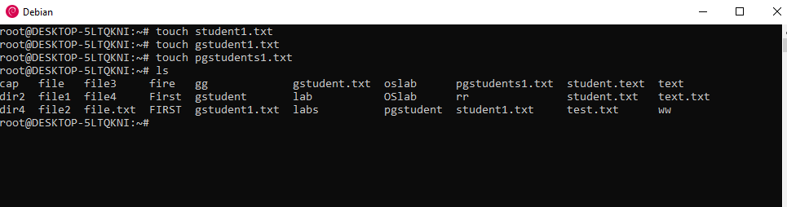

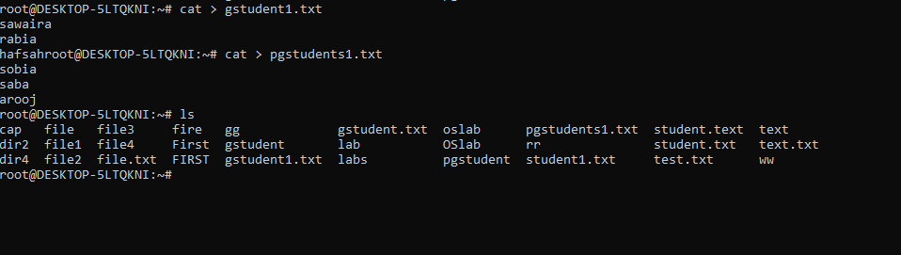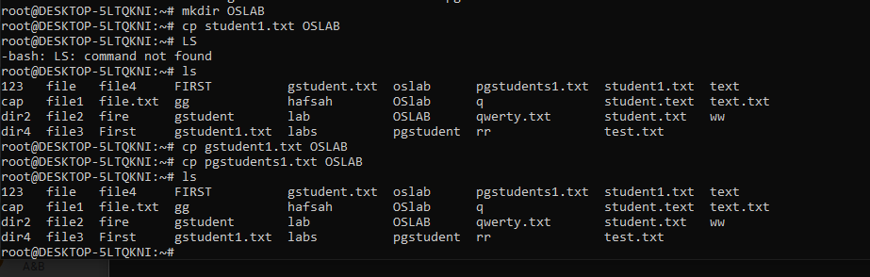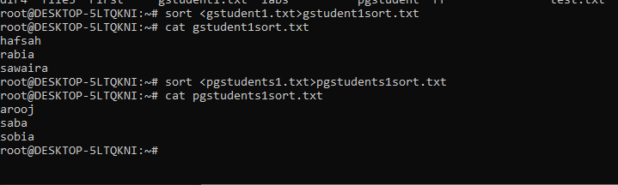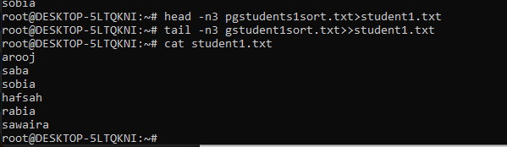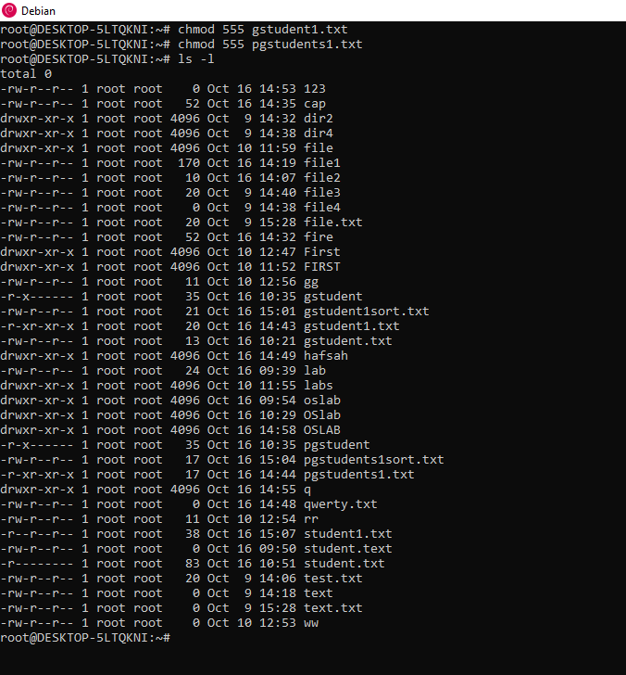

**Task #2**

Define variable x and y with value 20 and 30 and print it on screen, then sum, subtract, divide

these numbers and print it on the screen.

